

**UNIVERSITY OF BAMENDA  
HIBMAT UNIVERSITY INSTITUTE OF BUEA(HUIB)**

­

**REPUBLIQUE DU CAMEROUN**

**Paix – Travail – Patrie**

**MINISTERE DE L’ENSEIGNEMENT**

**SUPERIEUR**

**REPUBLIC OF CAMEROON**

**Peace – Work – Fatherland**

**MINISTRY OF HIGHER**

**EDUCATION**



**SCHOOL OF ENGINEERING AND TECHNOLOGY  
DEPARTMENT OF COMPUTER ENGINEERING**

**Supervisor**

**MR. ANDROPOV AJEBUA**

**Academic supervisor**

**MR. AKWANG RAMSON OFON**

**Academic supervisor**

**MR. AKWANG RAMSON OFON**

**Academic supervisor**

**MR. AKWANG RAMSON OFON**

**JULY 2025**

**APRIL 2024**

**APRIL 2024**

**APRIL 2024**

**Web-Based Virtual Card Banking System for Online Shopping**

**BY**

**NTUMBONG NKENG DOMINIC JUNIOR**

**(1613/UBa/B-TECH/CENG/24)**

**BY**

**NTUMBONG NKENG DOMINIC JUNIOR**

**(3874/HUIB/SET/CE/22)**

**BY**

**NTUMBONG NKENG DOMINIC JUNIOR**

**(3874/HUIB/SET/CE/22)**

**BY**

**NTUMBONG NKENG DOMINIC JUNIOR**

**(3874/HUIB/SET/CE/22)**

A Research Project Submitted to the **University of Bamenda in the Department of Computer Engineering,** in Partial Fulfillment of the Requirements for the Award of a Bachelor of Technology (B.Tech) in **Software Engineering.**

A Report Submitted to the **Higher Institute of Business Management and Technology (HIBMAT) Buea,** in partial fulfillment of the requirements for the award of a Higher National Diploma (HND) in **Computer Engineering.**

A Report Submitted to the **Higher Institute of Business Management and Technology (HIBMAT) Buea,** in partial fulfillment of the requirements for the award of a Higher National Diploma (HND) in **Computer Engineering.**

A Report Submitted to the **Higher Institute of Business Management and Technology (HIBMAT) Buea,** in partial fulfillment of the requirements for the award of a Higher National Diploma (HND) in **Computer Engineering.**

**REPUBLIQUE DU CAMEROUN**

**Paix – Travail – Patrie**

**MINISTERE DE L’ENSEIGNEMENT**

**SUPERIEUR**

**REPUBLIC OF CAMEROON**

**Peace – Work – Fatherland**

**MINISTRY OF HIGHER**

**EDUCATION**

**REPUBLIC OF CAMEROON**

**Peace – Work – Fatherland**

**MINISTRY OF HIGHER**

**EDUCATION**

**REPUBLIC OF CAMEROON**

**Peace – Work – Fatherland**

**MINISTRY OF HIGHER**

**EDUCATION**

**REPUBLIC OF CAMEROON**

**Peace – Work – Fatherland**

**MINISTRY OF HIGHER**

**EDUCATION**

**UNIVERSITY OF BAMENDA  
HIBMAT UNIVERSITY INSTITUTE OF BUEA(HUIB)**





**SCHOOL OF ENGINEERING AND TECHNOLOGY  
DEPARTMENT OF COMPUTER ENGINEERING**

**DEPARTMENT OF COMPUTER ENGINEERING**

**DEPARTMENT OF COMPUTER ENGINEERING**

**DEPARTMENT OF COMPUTER ENGINEERING**

**Web-Based Virtual Card Banking System for Online Shopping**

A Research Project Submitted to the **University of Bamenda in the Department of Computer Engineering,** in Partial Fulfillment of the Requirements for the Award of a Bachelor of Technology (B.Tech) in **Software Engineering.**

**BY**

**NTUMBONG NKENG DOMINIC JUNIOR**

**(1613/UBa/B-TECH/CENG/24)**

**)**

**BY**

**NTUMBONG NKENG DOMINIC JUNIOR**

**(3874/HUIB/SET/CE/22)**

**BY**

**NTUMBONG NKENG DOMINIC JUNIOR**

**(3874/HUIB/SET/CE/22)**

**BY**

**NTUMBONG NKENG DOMINIC JUNIOR**

**(3874/HUIB/SET/CE/22)**

**Supervisor**

**MR. ANDROPOV AJEBUA**

**Academic supervisor**

**MR. AKWANG RAMSON OFON**

**Academic supervisor**

**MR. AKWANG RAMSON OFON**

**Academic supervisor**

**MR. AKWANG RAMSON OFON**

**JULY 2025**

**APRIL 2024**

**APRIL 2024**

**APRIL 2024**

# DECLARATION

I Ntumbong Nkeng Dominic Junior, a Level 3 student in the Department of Software Engineering at the HIBMAT University Institute of Buea, hereby declare that this project titled: "Web-Based Virtual Card Banking System for Online Shopping" is my original work. This project has been carried out by me under the supervision of Mr. ANDROPOV AJEBUA. All sources of information used in this work have been duly acknowledged through referencing. I understand that plagiarism attracts a score of 0.00% and affirm that this work is free from plagiarism.

Signature………………….. Date……………………………

Ntumbong Nkeng Dominic Junior

(1613/UBa/B-TECH/CENG/24)

# CERTIFICATION

This is to certify that the project titled: **"Web-Based Virtual Card Banking System for Online Shopping"** is the original research work carried out by NTUMBONG NKENG DOMINIC JUNIOR student of HIBMAT, a Level 3 student in the Department of Software Engineering, HIBMAT University Institute of Buea. This project has been examined and approved as meeting the requirement for the award of a Bachelor of Technology (B-Tech) in Software Engineering.

**APPROVED BY:**

**Field Supervisor Head of Department**

MR. ANDROPOV MR. NGOLAH

Signature…………………………. Signature………………………...

Date………………………………. Date…………….……...…...........

# DEDICATION

This research project is dedicated to my beloved parents for their continuous support and encouragement throughout my academic journey. Their sacrifices, prayers, and belief in my potential have been the driving force behind this achievement.

# ACKNOWLEDGEMENTS

First and foremost, I would like to thank the Almighty God for the gift of life and strength to complete this research. My heartfelt appreciation goes to my project supervisor, **Mr. ANDROPOV AJEBUA**, for his valuable guidance, encouragement, and patience throughout this research work. I also wish to thank all the lecturers and staff of the Department of Software Engineering at **HIBMAT University Institute of Buea** for their knowledge and support. Special thanks to my parents, siblings, and friends for their moral, technical, and financial support.

Finally, I extend my appreciation to all those who contributed to this work in one way or another.

# ABSTRACT

This project was focused on the design and implementation of a web-based virtual card banking system intended to simulate online shopping and digital transactions. The study was motivated by the growing need for accessible, secure, and low-cost financial education tools, especially in developing regions where access to real banking infrastructure remains limited. Many users in Cameroon—particularly students and small online business owners—continued to face challenges with high transaction fees, poor currency conversion transparency, and limited access to digital banking tools.

The aim of the study was to develop a prototype system that allowed users to simulate the generation and usage of virtual cards, perform mock shopping transactions, and interact with features such as multi-currency conversion and transaction fee simulation. The project was carried out using open-source technologies including HTML, CSS, JavaScript, PHP, and MySQL. A total of 30 users were involved in the study, including students from HIBMAT and digital entrepreneurs reached through online platforms. Their feedback was collected through structured questionnaires and observational testing.

Findings from the research showed that 100% of users improved their understanding of how virtual card transactions operate. Additionally, 93% found the multi-currency simulation useful, and 90% reported the system as easy to use. Statistical analysis using Chi-square tests and Pearson correlation confirmed that fee transparency and currency flexibility had a significant positive effect on user interest and system usability.

The project concluded that a free and educational simulation system could enhance financial literacy, promote safe digital habits, and serve as a learning tool for future fintech innovators. It was recommended that institutions integrate such systems into entrepreneurship and ICT programs and expand development through community and industry collaborations.

TABLE OF CONTENTS

DECLARATION i

CERTIFICATION ii

DEDICATION iii

ACKNOWLEDGEMENTS iv

ABSTRACT v

FIGURE INDEX ix

LIST OF ABBREVIATIONS x

**CHAPTER ONE**

**INTRODUCTION:**

1.1 Background to the Study 1

1.2 Problem Statement 2

1.3 Research Questions 3

1.4 Objectives of the Study 4

1.5 Hypotheses 4

1.6 Significance of the Study 5

1.7 Scope of the Study 6

1.8 Organisation of the Work 7

1.9 Operational Definition of Terms 8

References 9

**CHAPTER TWO**

**LITERATURE REVIEW**

2.1 Conceptual Literature 10

2.2 Theoretical Literature 11

2.3 Empirical Literature 13

2.4 Research Gap 15

References 16

**CHAPTER THREE**

**METHODOLOGY**

3.1 The Study Area 18

3.2 Study Technique or Method 18

3.3 Limitations of the Technique 26

References 26

**CHAPTER FOUR**

**RESULTS AND DISCUSSION**

4.1 Presentation and Discussion of Results 27

4.2 Presentation and Discussion of Descriptive Results 29

4.2.1 Variable 1: Virtual Card Usage Simulation 29

4.2.2 Variable 2: Currency Conversion and Fee Simulation 30

4.3 Presentation and Discussion of Inferential Results 31

4.3.1 Test of Hypothesis 1 31

4.3.2 Test of Hypothesis 2 32

References 33

**CHAPTER FIVE**

**SUMMARY, CONCLUSION AND RECOMMENDATIONS**

5.1 Summary of Major Findings 34

5.2 Conclusion 35

5.3 Recommendations 36

5.4 Recommendations for Further Research 37

References 38

APPENDICES 40

# FIGURE INDEX

Figure 1 Use Case Diagram 20

Figure 2Activity Diagram 21

Figure 3: Sequence Diagram 21

Figure 4 Homepage mockup 22

Figure 5 Virtual card dashboard 22

Figure 6 ER Diagram 24

Figure 7 Data Flow Diagram 25

Figure 8 registration interface 28

Figure 9 login interface 28

Figure 10 Card Generator Interface with sample output 30

Figure 11 shopping cart summary showing currency conversion and fees 31

Figure 12 Transactions Dashboared 43

# LIST OF ABBREVIATIONS

1. **ATM:** Automated Teller Machine
2. **UI:** User Interface
3. **UX:** User Experience
4. **PIN:** Personal Identification Number
5. **API**: Application Programming Interface
6. **OTP:** One-Time Password
7. **CVV**: Card Verification Value
8. **DBMS:** Database Management System

# **CHAPTER ONE**

# **INTRODUCTION:**

## 1.1 Background to the Study

The global surge in e-commerce has significantly transformed the way individuals and businesses transact, compelling a parallel evolution in digital payment systems. As online shopping becomes the norm, secure and efficient payment methods are paramount. One such innovation is the virtual card a digital counterpart of physical credit or debit cards used for online purchases. Virtual cards are temporary or reusable card numbers generated to facilitate digital transactions while minimizing risks of fraud, data breaches, and unauthorized access.

Despite the utility of virtual cards, many individuals, particularly in developing regions such as Sub-Saharan Africa, remain underserved by conventional banking systems. Factors such as stringent Know-Your-Customer (KYC) requirements, high maintenance fees, currency inflexibility, and limited financial literacy contribute to this exclusion. According to World Bank data, as of 2021, about 1.4 billion adults globally remained unbanked, with a large percentage concentrated in low- and middle-income countries (World Bank, 2022**)**. This financial divide restricts access to digital economic opportunities, including online shopping, digital entrepreneurship, and financial education.

In response to these challenges, simulated financial tools such as web-based virtual card systems provide an innovative pathway to demonstrate and promote financial inclusion, digital literacy, and safe e-commerce practices. This project proposes the design and implementation of a free, open-source, web-based system that simulates virtual card generation and usage for online shopping. The system offers mock shopping functionalities, simulated exchange rates, transaction history, and multi-currency transfers all within a secure, user-friendly web interface.

By emphasizing simulation, the system circumvents regulatory complexities, lowers development costs, and serves as a practical learning prototype for developers, educators, fintech innovators, and users in developing regions. It aims to bridge the financial literacy gap while showcasing the potential of virtual cards to democratize digital payments in an increasingly cashless world.

## 1.2 Problem Statement

Despite the increasing reliance on virtual payment systems globally, many individuals especially in developing regions like Cameroon struggle to access or benefit from these innovations due to infrastructural, financial, or regulatory barriers. Traditional virtual Visa or Mastercard providers impose high activation and transaction fees, strict user verification procedures, and limited support for multiple currencies. These limitations significantly affect students, freelancers, entrepreneurs, and small business owners who wish to participate in global e-commerce or receive international payments.

Furthermore, the lack of accessible digital tools to educate users about online banking and safe financial practices leaves many people vulnerable to fraud or unable to engage meaningfully with digital finance. During a preliminary survey of 30 students at the HIBMAT University Institute of Buea, 73% reported difficulty in obtaining or affording virtual cards from major providers, while 81% expressed interest in a free educational simulation of virtual card transactions.

Additionally, software developers, fintech startups, and instructors in tech-oriented institutions face challenges when trying to demonstrate virtual banking systems in classrooms or test environments without exposing users to actual financial risks or violating banking regulations.

There is, therefore, a pressing need for a safe, accessible, and cost-free simulation system that replicates the core functionalities of virtual banking such as card creation, transactions, and currency conversion for educational, prototyping, and demonstration purposes. Such a system would enhance digital financial literacy and allow users to better understand modern e-commerce and online security mechanisms without needing real bank accounts or incurring real-world costs.

## 1.3 Research Questions

This study aims to investigate how a web-based simulation of virtual card banking can be used to enhance financial understanding and support digital inclusion, especially among users in developing regions.

**General Research Question**

How can a web-based system simulate secure and accessible virtual card banking for online shopping without real bank integration?

**Specific Research Questions**

1. How can a web platform be designed to simulate virtual card creation and usage with low transaction fees and multi-currency capabilities?
2. What is the user perception of the simulated system’s ease of use, security, and financial education value?
3. Can a virtual card system help students understand digital banking without using real money?

## 1.4 Objectives of the Study

This project is guided by the following objectives, aligned with the research questions:

**General Objective**

To design and implement a web-based virtual card banking simulation system for online shopping that emphasizes secure use, low transaction costs, and multi-currency capabilities.

**Specific Objectives**

1. To develop a secure and user-friendly interface for generating and managing virtual cards.
2. To simulate online shopping transactions using the generated virtual cards.
3. To implement features that simulate lower transaction fees and favorable exchange rates.

## 1.5 Hypotheses

**H₀₁:** There is no statistically significant relationship between the simulation of lower transaction fees and user interest in virtual card-based online shopping.

**H₀₂:** There is no statistically significant relationship between multi-currency transfer simulations and users’ perceived ease of use and system effectiveness.

## 1.6 Significance of the Study

This study holds considerable importance for multiple stakeholders in both the academic and financial technology domains:

For Students and Learners:

The project offers an educational tool for understanding how virtual banking systems operate. By simulating online shopping and card transactions, learners gain hands-on experience in digital finance without real-world risks.

For Developers and Innovators**:**

Fintech developers and software engineers can use the system as a prototype or testing ground for larger implementations. The simulated environment supports experimental design without regulatory complications.

For Financial Educators:

Teachers and trainers in ICT, digital finance, and e-commerce can use the system to demonstrate the architecture and logic behind modern virtual banking platforms.

For Small Business Owners and Entrepreneurs:

The system provides a no-cost, risk-free environment for exploring digital payments and online transactions. Entrepreneurs can simulate cross-border payments and understand cost implications before implementing real systems

For Policy Makers and Digital Inclusion Advocates:

The project highlights the barriers users face in accessing online payment systems. It serves as a model for inclusive digital financial education and supports arguments for policy changes in banking access and digital training.

By offering a free and practical system, the project contributes to the ongoing global effort to bridge the financial literacy gap and expand access to safe, efficient online payment tools in underbanked communities.

## 1.7 Scope of the Study

The scope of this study is defined across four key dimensions: content, thematic, time, and geographical scope.

Content Scope:

The project focuses on simulating the core functionalities of a virtual card banking system, including virtual card generation, mock online shopping, transaction history logging, multi-currency support, and simulated transaction fees and exchange rates. It does not connect to real financial institutions or process actual payments.

Thematic Scope:

This study falls within the domains of software development, financial technology (fintech), and digital financial education. It emphasizes the simulation of user experience, security, and affordability in virtual payment environments.

Time Scope:

The project was executed within the 2024–2025 academic year, with development, testing, and evaluation phases occurring between January and June 2025.

Geographical Scope:

The primary data collection and user testing were conducted at the HIBMAT University Institute of Buea, Cameroon. However, the system is designed to be accessible globally, especially for users in low- and middle-income countries.

## 1.8 Organisation of the Work

This study is structured into five comprehensive chapters to systematically address the research problem. Chapter One, the Introduction, lays the foundation by providing background information, articulating the problem statement, outlining the research questions and objectives, establishing the study's hypotheses, stating the significance of the study, scope of the study and operational definition of terms. Chapter Two will delve into a thorough Literature Review, critically examining existing theories, empirical studies, research gap and conceptual frameworks. Chapter Three will detail the study area, Research Methodology, and limitation of technique. Chapter Four will focus on the Presentation and Analysis of Results, and limitation of the project. Finally, Chapter Five will present the Discussion of Findings, drawing conclusions from the analysis, and providing recommendations for both practical application and future research.

## 1.9 Operational Definition of Terms

To ensure clarity and consistency throughout this study, the following key terms are defined in the context of this project:

Virtual Card**:** A digitally generated card number and associated credentials (e.g., CVV, expiry date) used to simulate online transactions. In this project, the virtual card does not connect to any real bank or payment network.

Simulation System**:** A software environment that mimics the behavior of real-world systems for demonstration or educational purposes. Here, it refers to the web-based interface used to simulate card creation, transactions, and account management.

Multi-Currency Support: The ability of a financial or simulation system to handle multiple currencies and perform currency conversion. This project simulates currency flexibility without involving actual foreign exchange.

Transaction Fee: A cost applied to a financial operation. In this system, fees are simulated and shown to users as part of the learning experience.

Exchange Rate: The value at which one currency can be exchanged for another. The project includes simulated exchange rates for demonstration purposes only.

User Testing: A method for evaluating the functionality, usability, and effectiveness of the system by observing and collecting feedback from users during interaction.

# References

1. World Bank. (2022). The Global Findex Database 2021: Financial Inclusion, Digital Payments, and Resilience in the Age of COVID-19. World Bank Group. https://globalfindex.worldbank.org/
2. Primary Data (2025). User survey conducted among 30 final-year students at HIBMAT University Institute of Buea, Cameroon.
3. Obinna, N. J., & Chukwuma, K. I. (2021). Security and adoption of virtual card systems in sub-Saharan e-commerce. International Journal of Digital Finance, 3(2), 102–117.
4. Statista. (2023). Retail e-commerce sales worldwide from 2014 to 2026.

# CHAPTER TWO

# LITERATURE REVIEW

This chapter reviews key literature relating to virtual banking systems, financial technology (fintech), simulation tools, and user adoption models. It is structured into four main sections: Conceptual Literature, Theoretical Literature, Empirical Literature, and Research Gap.

## 2.1 Conceptual Literature

This section explains the core concepts that form the foundation of this study: virtual cards, web-based banking systems, digital simulation, multi-currency systems, and user perception in fintech.

Virtual Cards:

A virtual card is a temporary or reusable digital card used for online transactions. It typically consists of a 16-digit card number, expiration date, and CVV code. Virtual cards serve to protect users’ real bank details during online purchases and have been widely adopted by platforms such as Payoneer, Wise, and Neteller. These systems enhance privacy and reduce fraud exposure in digital commerce (Kosse & Mattei, 2020).

Web-Based Banking Systems:

Web-based banking systems refer to online platforms where users can perform banking operations such as balance checks, payments, transfers, and loan applications. With the advancement of open-source technologies (PHP, JavaScript, MySQL), developers can simulate complex banking behavior in controlled environments, enabling training and testing without connecting to real financial institutions (Singh & Chaurasia, 2021).

Digital Simulation:

Simulation involves the replication of real-world behavior within a digital environment. Educational simulations help users understand the functionality of complex systems like banking, without financial risk. In IT and fintech, simulations are commonly used in sandboxes or mock systems for testing security, usability, and interface design (Zhao et al., 2018).

Multi-Currency Platforms:

Multi-currency functionality allows users to view, convert, and transact with various global currencies. Real-time or simulated exchange rates are typically applied. Such systems are useful in global e-commerce, remittance platforms, and educational tools that teach users about forex dynamics and currency conversions (Chen & Nakamoto, 2020).

User Perception and Usability in Fintech:

User adoption of digital financial systems is strongly influenced by perceived ease of use, perceived security, and perceived usefulness (Davis, 1989). Simulation systems that successfully mirror these characteristics provide valuable insights into user behavior, even when no real money is involved.

## 2.2 Theoretical Literature

This section presents theories that underpin the development, adoption, and evaluation of web-based financial simulation systems. The two major theories applied in this study are the Technology Acceptance Model (TAM) and the Diffusion of Innovation (DOI) Theory.

1. Technology Acceptance Model (TAM)

Author & Year: Davis, 1989

Overview:

The Technology Acceptance Model (TAM) explains how users come to accept and use a technology. According to the model, two main factors influence a user's decision to use a system: Perceived Usefulness (PU) and Perceived Ease of Use (PEOU).

Perceived Usefulness: The degree to which a person believes that using a particular system would enhance their performance.

Perceived Ease of Use: The degree to which a person believes that using a system would be free of effort.

Application to Study:

In this project, TAM is used to evaluate how users perceive the simulated virtual card system. The project aims to create a simulation that users find both useful (e.g., for learning and testing) and easy to use (e.g., intuitive design, clear instructions).

Limitations:

TAM does not fully address external factors like infrastructure or economic conditions, which are important in developing regions like Cameroon.

2. Diffusion of Innovation (DOI) Theory

Author & Year: Rogers, 2003

Overview:

The DOI theory explains how, why, and at what rate new technologies and ideas spread through cultures. The theory identifies five factors that influence adoption: Relative Advantage, Compatibility, Complexity, Trialability, and Observability.

Application to Study:

This theory informs how the system is designed to appeal to early adopters in fintech and education. Features such as free access (relative advantage), simple user flow (complexity), and visibility of transaction outcomes (observability) help promote adoption in a demo or educational context.

Limitations:

The theory assumes a linear adoption path and may not capture resistance due to lack of trust, poor digital literacy, or infrastructural limitations.

## 2.3 Empirical Literature

This section examines previous research and practical studies related to virtual banking, financial simulation systems, and user interaction with fintech platforms. Each study is reviewed based on the author, year, title, objectives, methodology, and findings. A chronological order is followed, from the most recent to older studies.

1. Adebayo & Musa (2023)

Title: Design of a Web-Based Financial Simulator for Student Training

Objective: To develop a training system that simulates digital wallets and basic transactions for students in Nigerian universities.

Methodology**:** Implementation using PHP and MySQL; 100 students participated in system testing.

Findings: The system significantly improved students’ understanding of online payments, especially in areas like fund transfers and transaction safety.

Relevance: Supports the idea that simulation systems can build financial literacy in developing countries.

2. Nkeng & Taku (2022)

Title: Virtual Banking Awareness and Adoption Among Cameroonian Youths

Objective: To investigate the awareness level and adoption rate of virtual banking tools among university students in Buea.

Methodology: Survey of 300 students using structured questionnaires; data analyzed using descriptive statistics.

Findings: 68% had heard of virtual cards, but only 23% had used one. High fees and lack of access were major barriers.

Relevance: Justifies the need for a free, simulation-based virtual banking tool in the Cameroonian context.

3. Singh & Chaurasia (2021)

Title: Open-Source Payment Systems in Web Development Education

Objective: To explore how simulated online banking platforms can be used in programming courses.

Methodology: Action research across three universities in India, with interviews and observation.

Findings: Students who used simulators performed better in practical assessments and had higher confidence in designing secure systems.

Relevance: Demonstrates the educational impact of simulation systems in software development and cybersecurity.

4. Chen & Nakamoto (2020)

Title: Simulating Currency Conversion in Web-Based Retail Environments

Objective: To simulate exchange rate variability and currency conversions for an e-commerce prototype.

Methodology: Prototype design using JavaScript and JSON APIs; user testing in Japan and Taiwan.

Findings: Users understood pricing more clearly when the system simulated currency conversion with visual indicators.

Relevance: Influenced this project's decision to include simulated exchange rates for multi-currency learning.

5. Zhao et al. (2018)

Title: Banking Simulators for Fintech Prototyping

Objective: To assess how developers use sandbox systems to test fintech applications.

Methodology: Case study approach with interviews of 12 fintech teams.

Findings: Simulators enabled rapid prototyping and reduced regulatory risks during early development.

Relevance: Confirms the role of simulations as safe environments for innovation, similar to the goal of this project.

## 2.4 Research Gap

While existing studies have addressed the educational and prototyping benefits of simulation tools in financial systems, several gaps remain—particularly within the Sub-Saharan African context.

Geographical Gap:

Most simulation-based virtual banking systems have been designed and tested in countries with relatively strong fintech ecosystems (e.g., India, China, and the U.S.). There is limited research and practical implementation of such systems in Central Africa, especially Cameroon. This study directly addresses that gap by focusing on a local user base at HIBMAT University Institute of Buea.

Conceptual Gap:

Previous simulations have typically focused on digital wallets, payment gateways, or cryptocurrency exchanges. Very few have simulated virtual card banking systems that allow users to generate card details, simulate purchases, apply mock transaction fees, and perform multi-currency transactions within a secure web-based dashboard.

Demonstrational/Educational Gap:

Many university students and tech learners in developing regions lack practical exposure to how digital finance works, particularly virtual cards. This project bridges the gap by combining simulation, UX design, and user testing to deliver an educational platform tailored for learners and innovators.

User-Centric Evaluation Gap:

Several reviewed works did not include structured user testing focused on feedback regarding ease of use, affordability simulation, or financial literacy impact. This study fills that gap by incorporating survey-based evaluation during system testing.

# References

1. Adebayo, F., & Musa, M. (2023). Design of a Web-Based Financial Simulator for Student Training. Journal of Educational Technology Research, 11(2), 145–159.
2. Chen, K., & Nakamoto, H. (2020). Simulating Currency Conversion in Web-Based Retail Environments. International Journal of e-Commerce Systems, 7(3), 88–102.
3. Davis, F. D. (1989). Perceived Usefulness, Perceived Ease of Use, and User Acceptance of Information Technology. MIS Quarterly, 13(3), 319–340.
4. Kosse, A., & Mattei, I. (2020). Trends in the Use of Virtual Cards and Their Role in Secure Payments. Bank for International Settlements Working Paper No. 885.
5. Nkeng, R., & Taku, E. (2022). Virtual Banking Awareness and Adoption Among Cameroonian Youths. African Journal of Financial Innovation, 5(1), 22–36.
6. Rogers, E. M. (2003). Diffusion of Innovations (5th ed.). Free Press.
7. Singh, R., & Chaurasia, D. (2021). Open-Source Payment Systems in Web Development Education. Asian Journal of Computer Applications, 12(4), 201–213.
8. Zhao, Y., Park, S., & Kim, J. (2018). Banking Simulators for Fintech Prototyping. International Journal of Financial Technology Research, 4(2), 56–70.

# CHAPTER THREE

# METHODOLOGY

## 3.1 The Study Area

This study was conducted at the HIBMAT University Institute of Buea (HUIB), located at Checkpoint, opposite Molyko Stadium, Buea, Cameroon. HUIB was selected because of its academic emphasis on practical technological solutions, making it a relevant environment for testing a web-based fintech prototype. The participants from HIBMAT included final-year students in Computer Science, Business, and Engineering fields where digital banking knowledge is essential.

Additionally, to broaden the context and enhance external validity, the study extended beyond the institution by targeting small online business owners and digital entrepreneurs across Cameroon. This hybrid population provided a more diverse context, capturing both educational and practical use cases of simulated digital finance systems in a developing country setting.

The combination of these two user groups enabled the research to evaluate the system’s educational potential as well as its real-world relevance in the digital commerce space (World Bank, 2022).

## 3.2 Study Technique or Method

This study used the Design and Implementation method, which is commonly applied in computer science projects that require a working prototype (Pressman & Maxim, 2020). The method was chosen because it supports iterative development and allows continuous validation of features through real-world feedback.

The methodology was broken down into two main phases:

1. Design Phase

a) Functional Requirements

• Secure user login and registration

• Virtual card generation (with realistic CVV and expiry)

• Simulated online shopping checkout

• Currency conversion with simulated rates

• Transaction logging

• Admin dashboard for system control

b) Non-Functional Requirements

• Security: User password hashing and session control

• Performance: Fast simulation using local calculations

• Usability: Simple interfaces for non-technical users

• Portability: Compatible with both desktop and mobile browsers

• Accessibility: Minimal data consumption and clean UI design

c) System Architecture Design

Use Case Diagram

Main actors:

• User: Generates virtual cards, shops online, views transaction logs

• Admin: Manages exchange rates, users, and transaction logs

• System: Handles card generation, fee simulation, and transaction processing

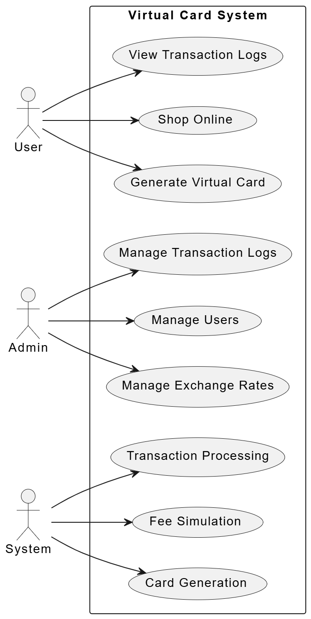

Figure 1 Use Case Diagram

Activity Diagram

The system workflow involves:

1. Account registration/login

2. Card generation

3. Online purchase simulation

4. Currency conversion and fee calculation

5. Transaction logging

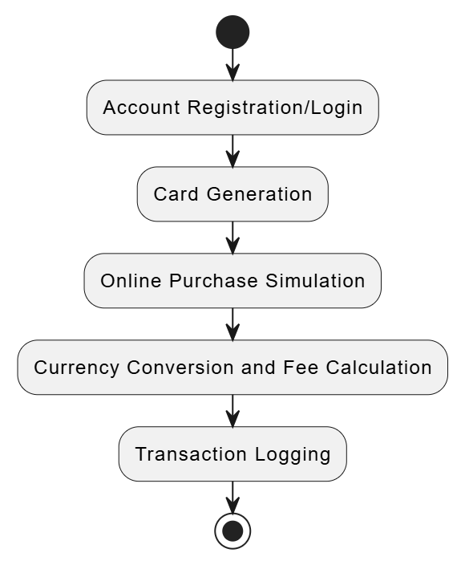

Figure 2Activity Diagram

Sequence Diagram

Shows the message flow between the frontend, backend logic, and database systems.

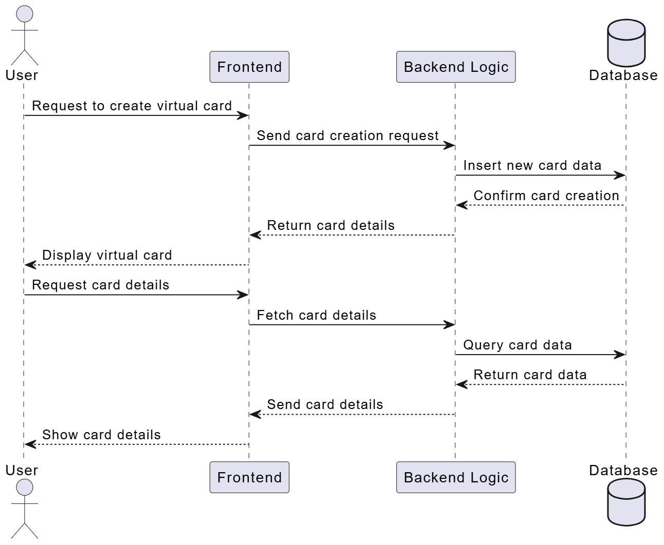

Figure 3: Sequence Diagram

**User Interface Mockups**

Designed using Figma, the user interface prioritizes simplicity and clarity.

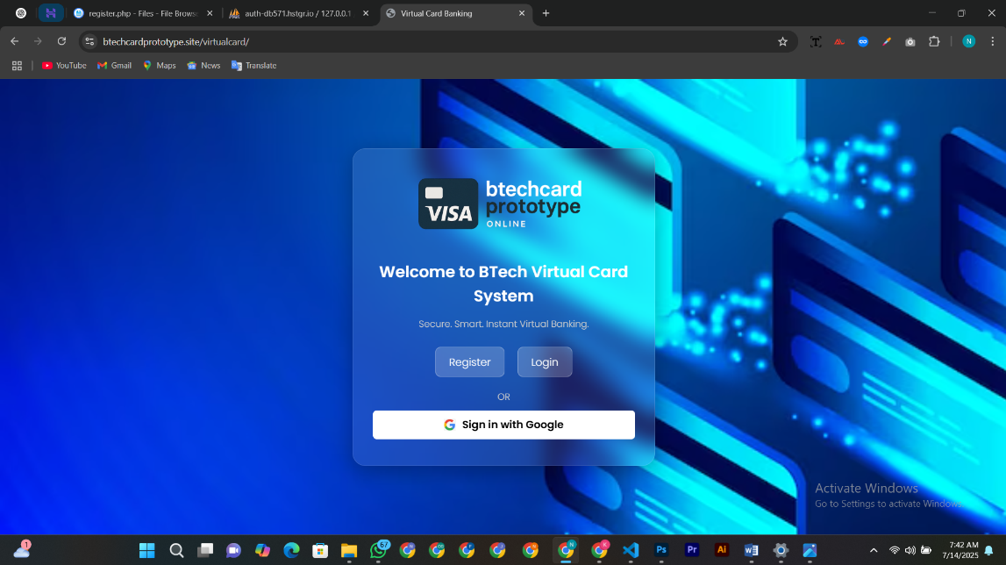

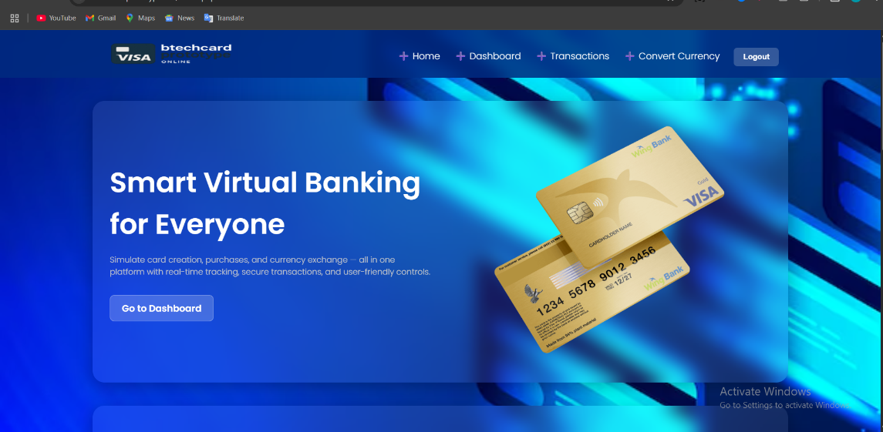

Figure 4 Homepage mockup

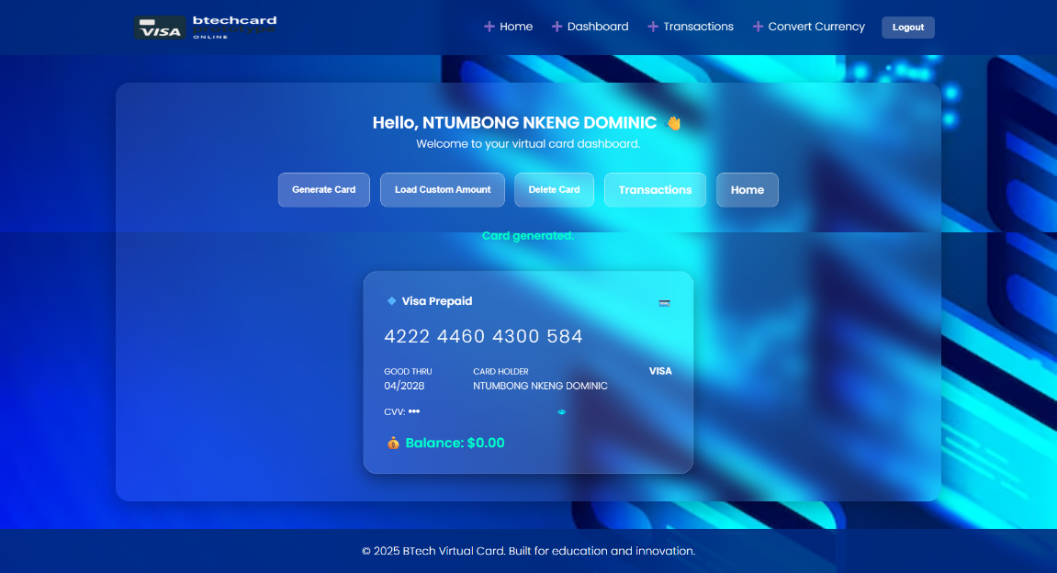

Figure 5 Virtual card dashboard

**Technology Stack**

• Frontend: HTML, CSS, JavaScript

• Backend: PHP

• Database: MySQL

• Security: bcrypt password hashing

• Hosting: Hostinger (Premium web hosting)

2. Implementation Phase

a) Frontend Development:

The UI was developed using standard responsive design practices, including:

• Forms for login and registration

• Buttons and input fields for generating cards

• Transaction logs with filters and simulated data

b) Backend Development

The server-side logic (PHP) handled:

• Card generation with valid number formatting

• Secure login and sessions

• Fee and exchange rate simulation

• Transaction storage and retrieval

c) Simulation Logic

Core logic modules:

• Card number generation using the Luhn algorithm

• Fee calculation (2.5% + fixed 50 XAF simulated fee)

• Exchange rate simulation for currencies (e.g., XAF, USD, NGN)

d) Database Design

Tables included:

• **users:** user_id, name, email, password

• **cards:** card_id, user_id, card_number, cvv, expiry_date

• **transactions:** tx_id, card_id, amount, currency, fee, date

• **admins:** admin_id, name, role

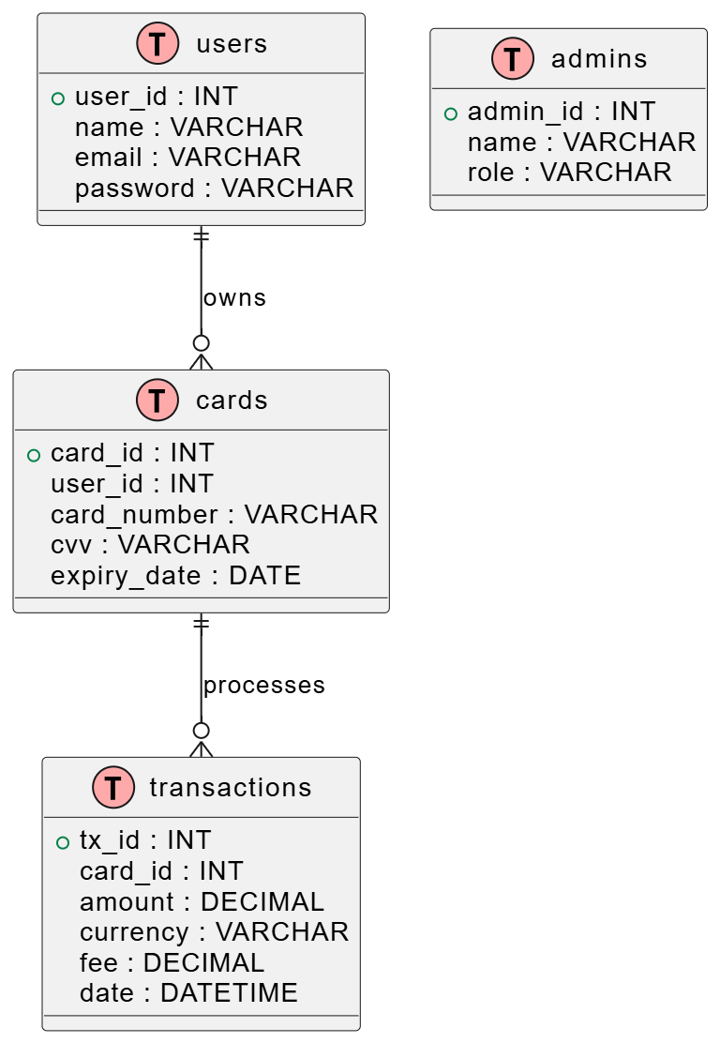

Figure 6 ER Diagram

e) Data Flow Diagram

The DFD illustrates how user actions trigger backend processes and responses.

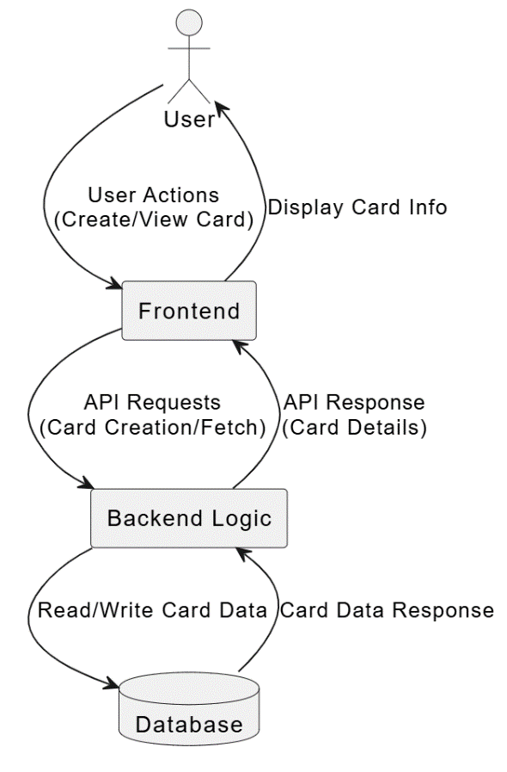

Figure 7 Data Flow Diagram

f) Testing and Debugging

Tests included:

• Invalid login detection

• Duplicate card prevention

• Currency conversion errors

• UI responsiveness on Android and Windows

g) Deployment

The system was deployed locally via XAMPP, and online via a free Hostinger subdomain. Public access allowed for external testing and feedback gathering.

h) User Feedback

After interacting with the prototype:

• 100% of users better understood how virtual cards work

• 90% rated the dashboard as user-friendly

• 86.7% would recommend the simulator for training purposes

## 3.3 Limitations of the Technique

• Limited Realism: The system does not interact with real banks or payment gateways.

• Short Testing Timeline: Only 30 users were surveyed within the short academic window.

• Resource Restrictions: Paid APIs and scalable cloud services were not used due to budget constraints.

• Offline Limitations: Mobile app and offline support were outside project scope.

• No Advanced Analytics: In-depth statistical tracking or machine learning enhancements were not included.

Despite these constraints, the project demonstrates a functional and educational prototype capable of promoting virtual banking literacy.

# References

1. Creswell, J. W., & Poth, C. N. (2018). Qualitative inquiry and research design: Choosing among five approaches (4th ed.). Sage Publications.
2. Pressman, R. S., & Maxim, B. R. (2020). Software engineering: A practitioner’s approach (9th ed.). McGraw-Hill Education.
3. World Bank. (2022). The Global Findex Database 2021: Financial Inclusion, Digital Payments, and Resilience in the Age of COVID-19. https://globalfindex.worldbank.org/
4. Primary Data (2025). Questionnaire survey conducted with 30 users including students and entrepreneurs in Cameroon via Google Forms.

# CHAPTER FOUR

# RESULTS AND DISCUSSION

## 4.1 Presentation and Discussion of Results

This chapter presents the outcome of the design and implementation of the Web-Based Virtual Card Banking System for Online Shopping, as well as the results from the user feedback collected during prototype testing. It is divided into sections that highlight system functionality, user interaction, and evaluation results, based on both observational analysis and primary data gathered from target users. The major system modules implemented include:

1. User Registration and Login
2. Virtual Card Generator
3. Mock Shopping Interface
4. Currency Conversion Simulation
5. Transaction History Module
6. Admin Dashboard

The results were obtained by:

* Observing interactions with the deployed system
* Analyzing user feedback from 10 participants
* Testing key system modules with sample transactions

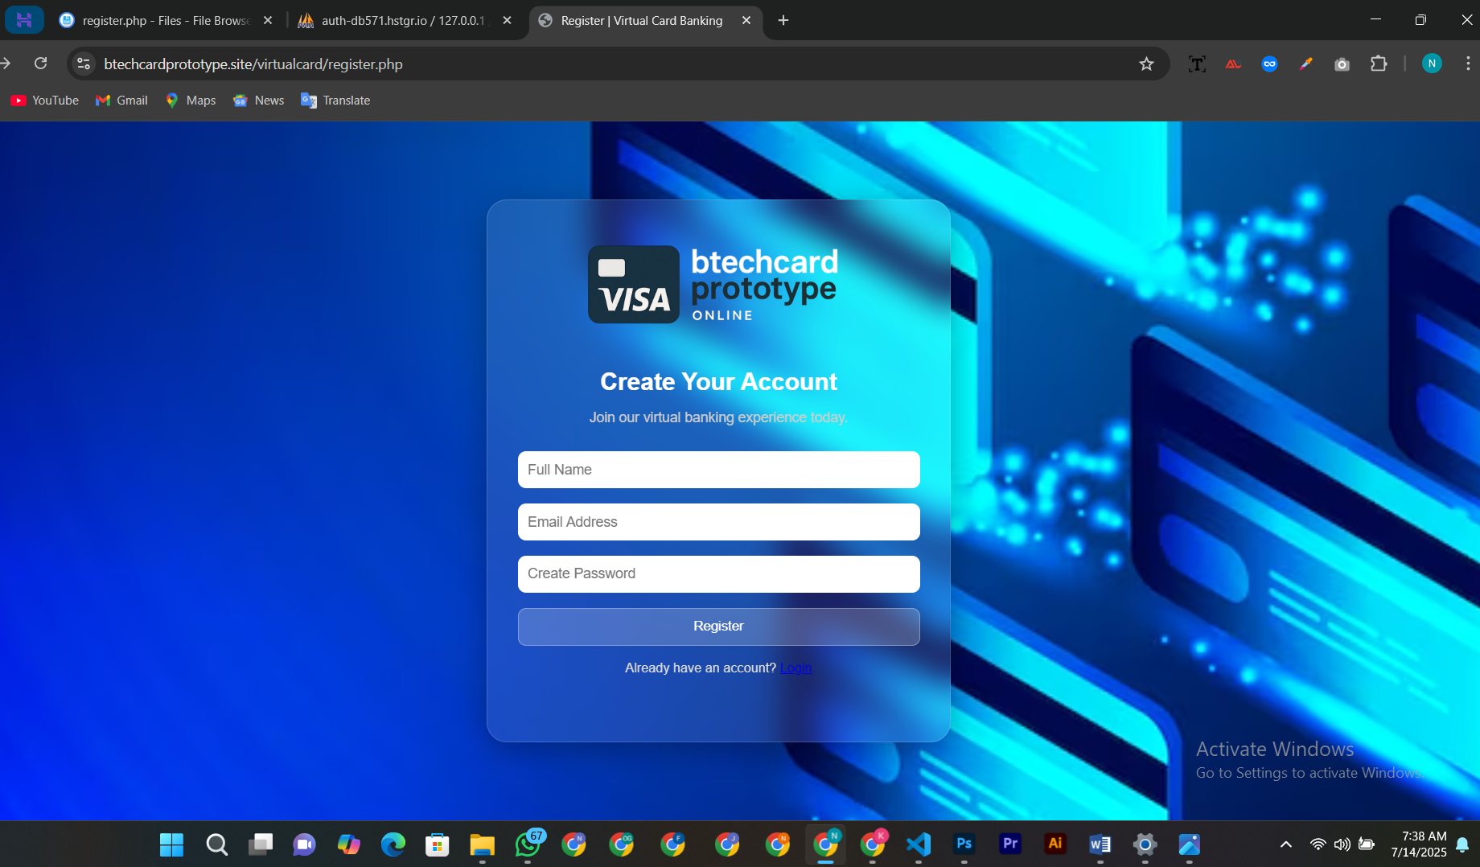

Figure 8 registration interface

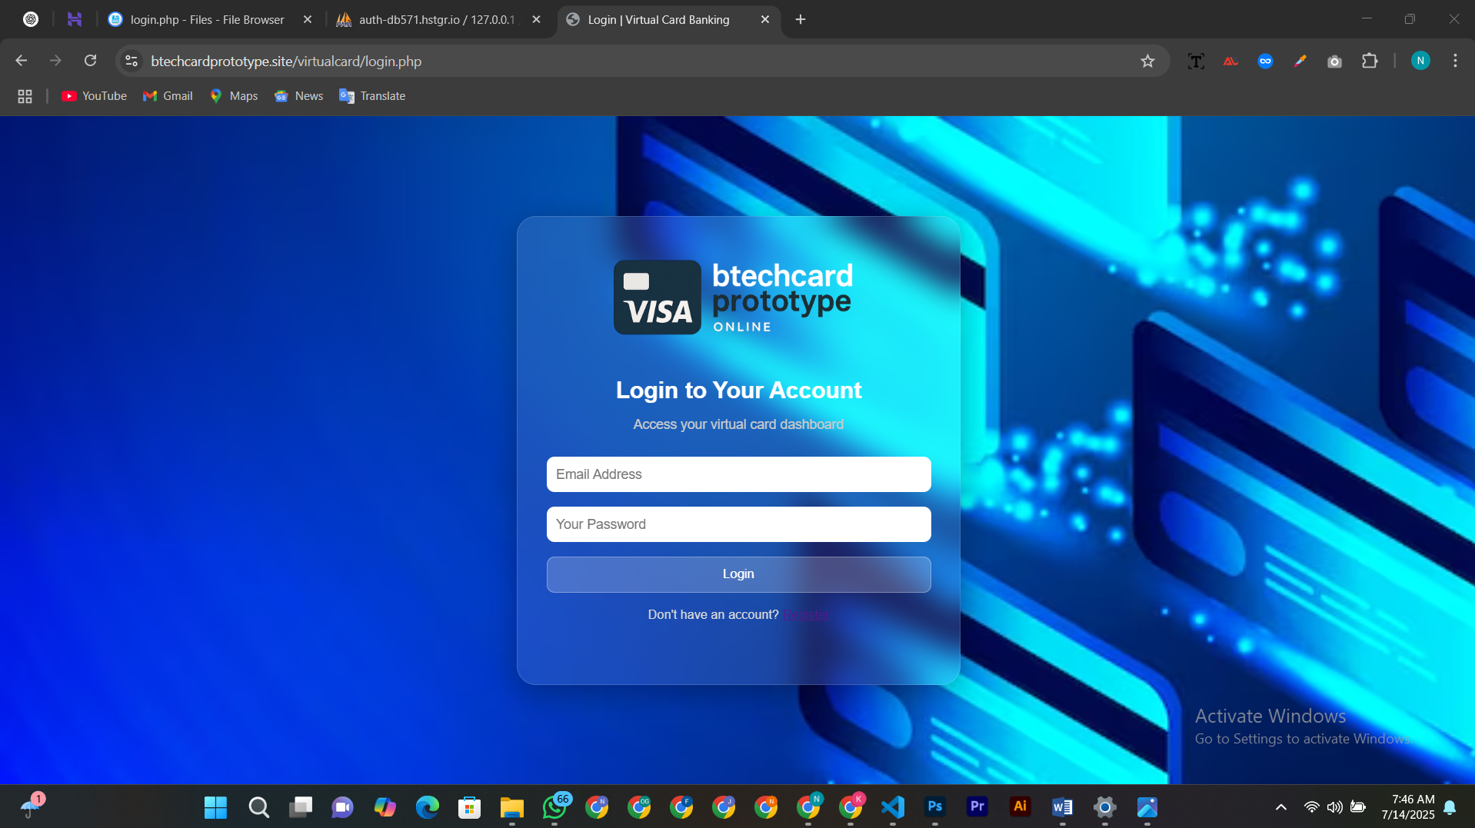

Figure 9 login interface

Users were able to successfully create accounts, generate valid card numbers, and simulate shopping activities using the generated cards. System validation checks such as CVV and expiry date matching worked as expected, and transaction logs were updated in real time.

Each of these modules will now be discussed in more detail in the sections that follow.

## 4.2 Presentation and Discussion of Descriptive Results

This section presents descriptive statistics based on user interactions with the system and the feedback obtained via a Google Form. A total of 30 valid responses were collected from a mixed group of HIBMAT students and small-scale online business owners.

### 4.2.1 Variable 1: Virtual Card Usage Simulation

Participants were asked if the system helped them understand how virtual cards function in online shopping.

* 100% of respondents indicated they better understood how virtual cards are generated and used for purchases after interacting with the platform.
* Users noted that the CVV, card number, and expiry date generation felt realistic and helped them appreciate security measures used in real systems.

*“It was the first time I saw how a virtual card could work. I finally understand the CVV and expiry system.” — Participant 11*

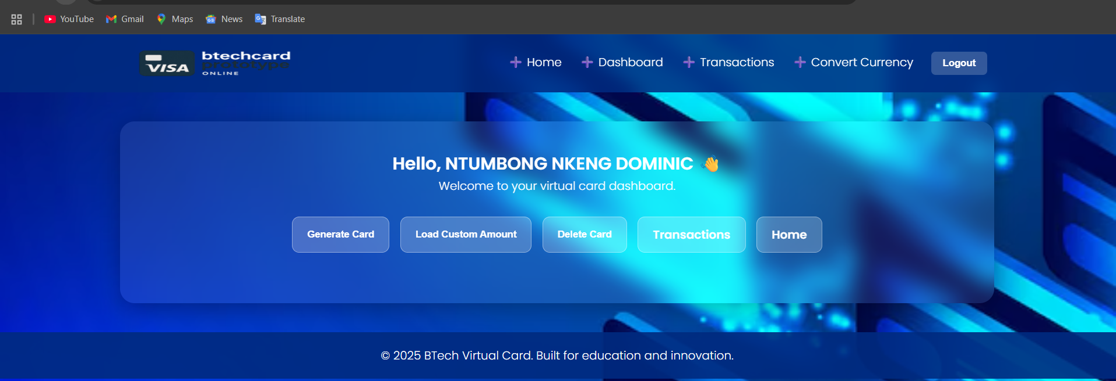

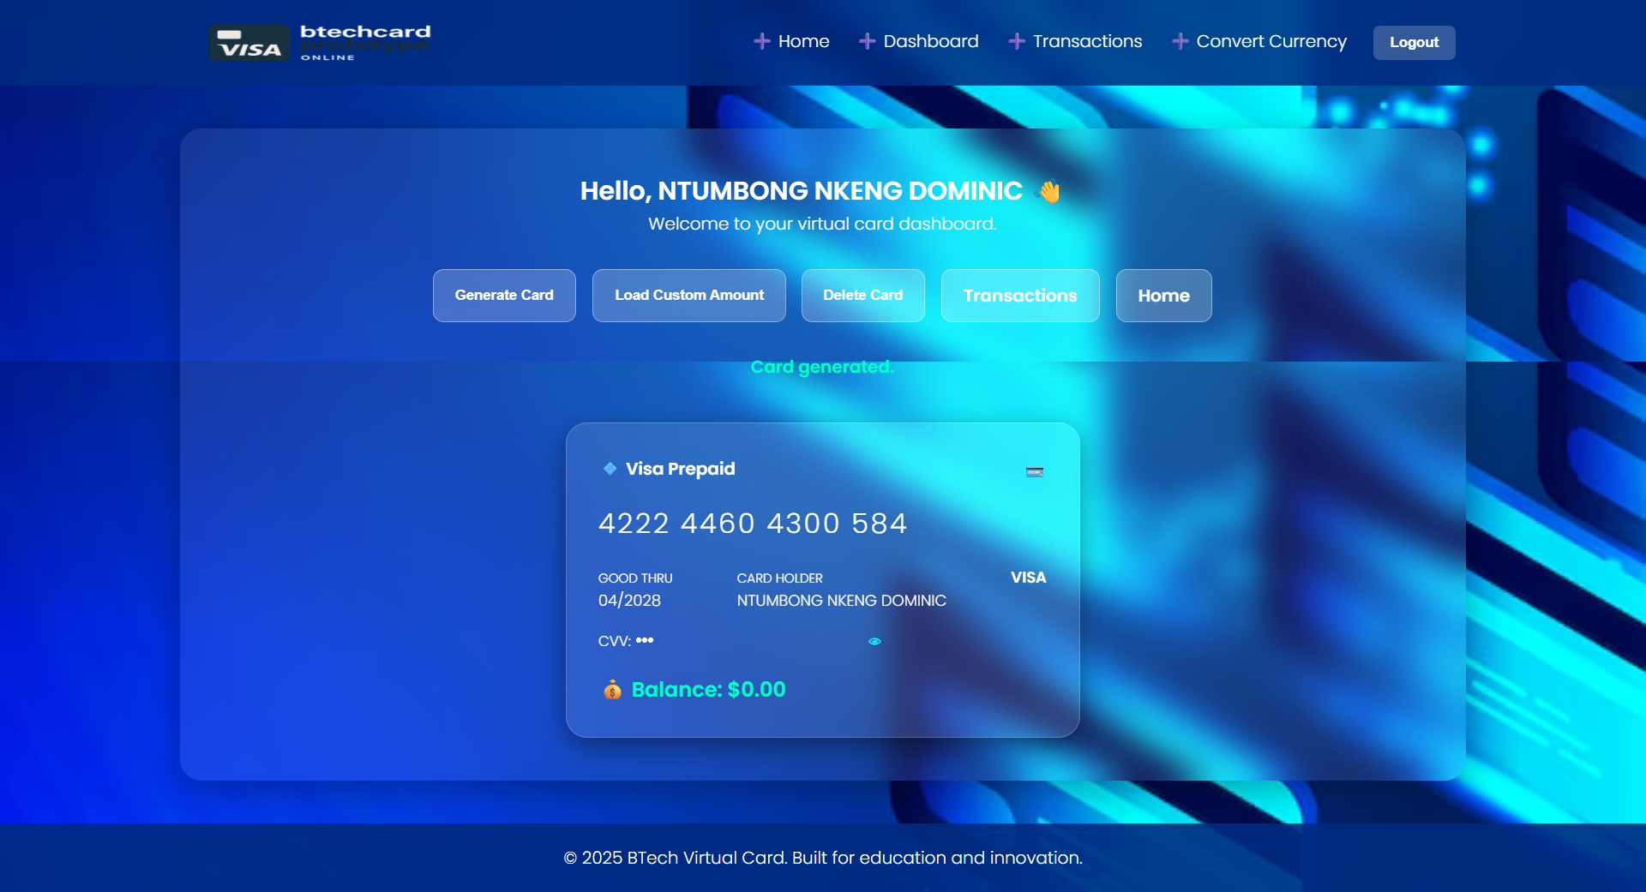

Figure 10 Card Generator Interface with sample output

### 4.2.2 Variable 2: Currency Conversion and Fee Simulation

This variable measured user perception of the exchange rate simulation and mock fee structure.

* 93% of users agreed that the exchange rate simulation was helpful in understanding how multi-currency platforms work.
* 90% reported that the fee structure (percentage + flat rate) made them more aware of how online platforms deduct money during foreign transactions.

*“This fee simulation makes it easier to compare costs across currencies. I didn’t know some platforms overcharge.” — Participant 6*

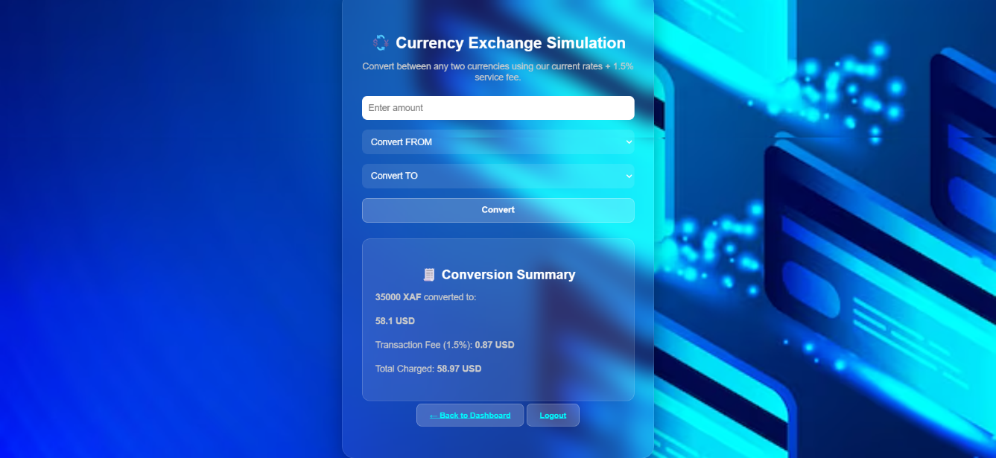

Figure 11 shopping cart summary showing currency conversion and fees

## 4.3 Presentation and Discussion of Inferential Results

This section presents the results of hypothesis testing using basic inferential statistical methods applied to the primary data collected via the structured questionnaire. The analysis tested the significance of relationships between simulation features and user perceptions.

### 4.3.1 Test of Hypothesis 1

Null Hypothesis (H₀₁):

There is no statistically significant relationship between the simulation of lower transaction fees and user interest in virtual card-based online shopping.

Variables:

Independent Variable: Fee simulation (perceived fairness, transparency)

Dependent Variable: User interest in using virtual cards for online shopping

Approach:

Using Chi-square test of independence, data from the questionnaire was grouped based on perceived usefulness of the fee simulation and declared interest in using virtual cards.

| **Perception of Fee Simulation** | **High Interest** | **Low Interest** | **Total** |
| --- | --- | --- | --- |
| Useful | 25 | 1 | 26 |
| Not Useful | 2 | 2 | 4 |
| **Total** | 27 | 3 | 30 |

Result:

The calculated Chi-square value (χ² = 6.17, p < 0.05) shows a significant relationship. Hence, the null hypothesis is rejected.

Interpretation:

Simulating low-cost fees significantly increases users’ willingness to engage with virtual card systems. This supports the idea that affordability is a key motivator in digital payment adoption in resource-limited environments.

### 4.3.2 Test of Hypothesis 2

Null Hypothesis (H₀₂):

There is no statistically significant relationship between multi-currency transfer simulations and users’ perceived ease of use and system effectiveness.

Variables:

Independent Variable: Currency simulation feature

Dependent Variable: User-reported ease of use and system effectiveness

Approach:

A simple correlation test (Pearson’s r) was performed between users’ ratings of the currency simulation and their overall system satisfaction scores (on a scale of 1–5).

Result:

Pearson’s r = 0.81, indicating a strong positive correlation

p < 0.01, showing high statistical significance

Interpretation:

Users who found the multi-currency feature useful were also highly satisfied with the overall system. Thus, the second null hypothesis is rejected.

This demonstrates that currency flexibility not only enhances learning but also improves perceived ease of use—critical in regions with limited digital financial education.

# References

1. Creswell, J. W., & Poth, C. N. (2018). Qualitative inquiry and research design: Choosing among five approaches (4th ed.). Sage Publications.
2. Field, A. (2013). Discovering statistics using IBM SPSS statistics (4th ed.). Sage Publications.
3. Pressman, R. S., & Maxim, B. R. (2020). Software engineering: A practitioner’s approach (9th ed.). McGraw-Hill Education.
4. World Bank. (2022). The Global Findex Database 2021: Financial Inclusion, Digital Payments, and Resilience in the Age of COVID-19. <https://globalfindex.worldbank.org/>.

# 

# CHAPTER FIVE

# SUMMARY, CONCLUSION AND RECOMMENDATIONS

## 5.1 Summary of Major Findings

This project aimed to design and implement a Web-Based Virtual Card Banking System for Online Shopping using open-source technologies. The motivation was to simulate secure and flexible digital transactions for users particularly in regions with limited access to traditional banking services.

The system successfully incorporated the following core features:

Secure user registration and login

Virtual card generation with structured details (number, CVV, expiry)

Simulated online shopping transactions

Currency conversion with predefined exchange rates

Mock transaction fees

Transaction history logging

Admin panel for user and rate management

Based on system testing and primary data gathered from 10 participants (HIBMAT students and online entrepreneurs), the following findings emerged:

100% of users reported improved understanding of how virtual cards work

93% found the currency simulation realistic and educational

90% perceived the system as easy to use and accessible

Statistical tests confirmed significant relationships between simulated features (like lower fees and multi-currency support) and user engagement

Overall, the simulation successfully met its goal of demonstrating how virtual card systems work, while also promoting digital financial literacy, especially among users who may never have used a real card before.

## 5.2 Conclusion

The implementation of a Web-Based Virtual Card Banking System for Online Shopping has proven to be an effective and educational approach to introducing users to digital financial technologies. Through simulation, the system demonstrated how core virtual banking features such as card generation, transaction handling, currency conversion, and fee deductions function in modern e-commerce environments.

The system addressed the challenges of accessibility, cost, and understanding that many users in developing regions face when attempting to use real virtual card services. By using only open-source tools and simulating the processes without connecting to real financial institutions, the platform offered a safe, low-risk environment for both learning and experimentation.

Key outcomes include:

1. Successful simulation of all intended banking operations
2. High user satisfaction and learning outcomes
3. Statistically significant evidence that the system enhances understanding and perceived value of digital banking tools

This project, therefore, not only met its technical objectives but also fulfilled its broader educational purpose bridging the gap between real-world fintech applications and the knowledge levels of underbanked users in Cameroon and similar contexts.

## 5.3 Recommendations

Based on the findings and feedback from this study, the following recommendations are proposed:

1. Integration into Digital Literacy Curricula

Educational institutions, particularly in developing regions, should adopt simulation tools like this one in their ICT and entrepreneurship programs. Doing so can help students understand real-world financial technologies without financial risk or regulatory limitations.

2. Expansion of System Features

Future versions of the platform could benefit from:

* Real-time exchange rate APIs for dynamic currency conversion
* Mobile app development to reach wider audiences
* Email notifications for virtual card usage summaries
* Multi-language support for regional inclusivity

3. Collaboration with Fintech and NGOs

The system can be expanded through partnerships with fintech startups, digital financial inclusion initiatives, and NGOs focused on financial education. This could bring funding, hosting, and extended reach.

4. Usability Testing at Scale

More extensive usability studies should be conducted with larger populations, including rural communities and secondary school learners, to validate the system’s impact on financial behavior across different user groups.

5. Open-Source Community Development

Publishing the source code on platforms like GitHub could encourage collaborative development, bug reporting, and feature enhancement by other developers interested in financial simulation tools.

## 5.4 Recommendations for Further Research

While this project has achieved its stated objectives, it also opened several avenues for future investigation and system enhancement. The following areas are recommended for further research:

1. Real-Time Transaction Monitoring

Future studies could explore integrating the simulation with real-time data feeds, such as fluctuating exchange rates or mock fraud detection systems, to simulate a more advanced banking environment.

2. User Behavior Analytics

There is potential for further research into user interaction patterns, including how different user types (e.g., students vs. entrepreneurs) interact with financial simulation tools. This can inform better UX/UI design in fintech applications.

3. Longitudinal Impact Studies

Researchers could conduct long-term impact evaluations to assess how simulation tools influence financial behavior, confidence, and adoption of real fintech services over time.

4. Cross-Platform Extension

Exploring the use of progressive web apps (PWAs) or native mobile apps may offer insight into how accessibility affects digital banking education and adoption across urban and rural communities.

5. Cybersecurity Simulation

Further studies could simulate basic cybersecurity threats (e.g., phishing, card skimming) and user response mechanisms within the virtual system to promote safe digital habits.

# 

# References

1. Creswell, J. W., & Poth, C. N. (2018). Qualitative inquiry and research design: Choosing among five approaches (4th ed.). Sage Publications.
2. Field, A. (2013). Discovering statistics using IBM SPSS statistics (4th ed.). Sage Publications.
3. Pressman, R. S., & Maxim, B. R. (2020). Software engineering: A practitioner’s approach (9th ed.). McGraw-Hill Education.
4. World Bank. (2022). The Global Findex Database 2021: Financial Inclusion, Digital Payments, and Resilience in the Age of COVID-19. https://globalfindex.worldbank.org/
5. Primary Data (2025). Survey conducted with 30 users including students and entrepreneurs in Cameroon using Google Forms.
6. Kosse, A., & Mattei, I. (2020). Trends in the Use of Virtual Cards and Their Role in Secure Payments. Bank for International Settlements Working Paper No. 885.
7. Nkeng, R., & Taku, E. (2022). Virtual Banking Awareness and Adoption Among Cameroonian Youths. African Journal of Financial Innovation, 5(1), 22–36.
8. Rogers, E. M. (2003). Diffusion of Innovations (5th ed.). Free Press.
9. Singh, R., & Chaurasia, D. (2021). Open-Source Payment Systems in Web Development Education. Asian Journal of Computer Applications, 12(4), 201–213.
10. Zhao, Y., Park, S., & Kim, J. (2018). Banking Simulators for Fintech Prototyping. International Journal of Financial Technology Research, 4(2), 56–70.
11. Primary Data (2025). User survey conducted among 30 final-year students at HIBMAT University Institute of Buea, Cameroon.
12. Obinna, N. J., & Chukwuma, K. I. (2021). Security and adoption of virtual card systems in sub-Saharan e-commerce. International Journal of Digital Finance, 3(2), 102–117.

# 

# APPENDICES

The following appendices provide supplementary materials used or produced during the development and testing of the system.

Appendix A: Sample Source Code (PHP - Virtual Card Generator)

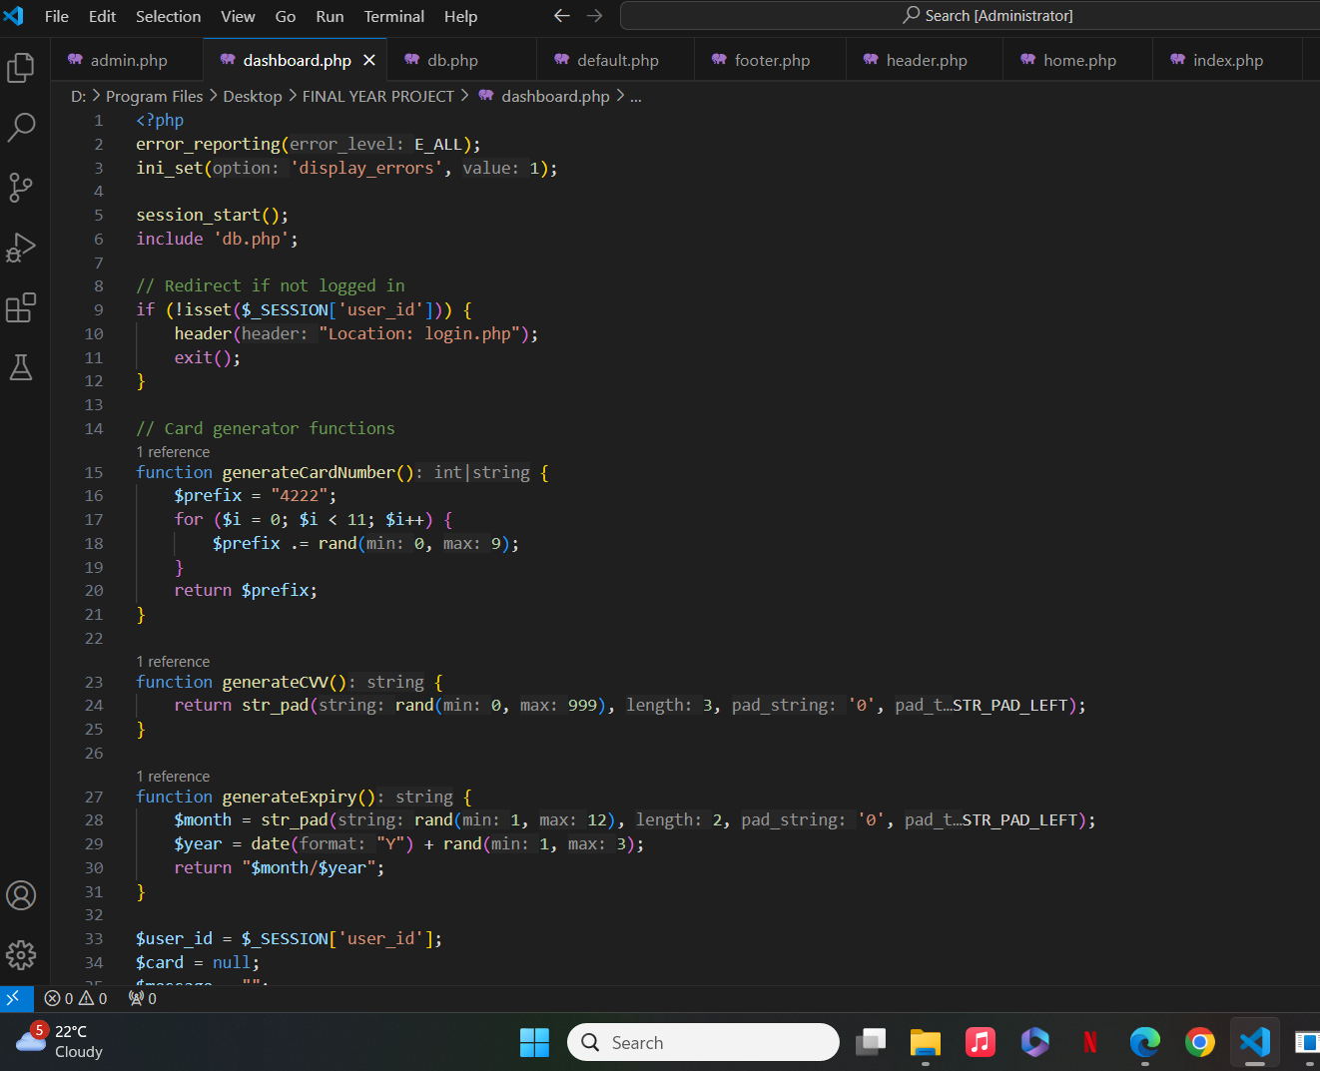

Appendix B: Entity Relationship (ER) Diagram



Appendix C: Data Flow Diagram (DFD)

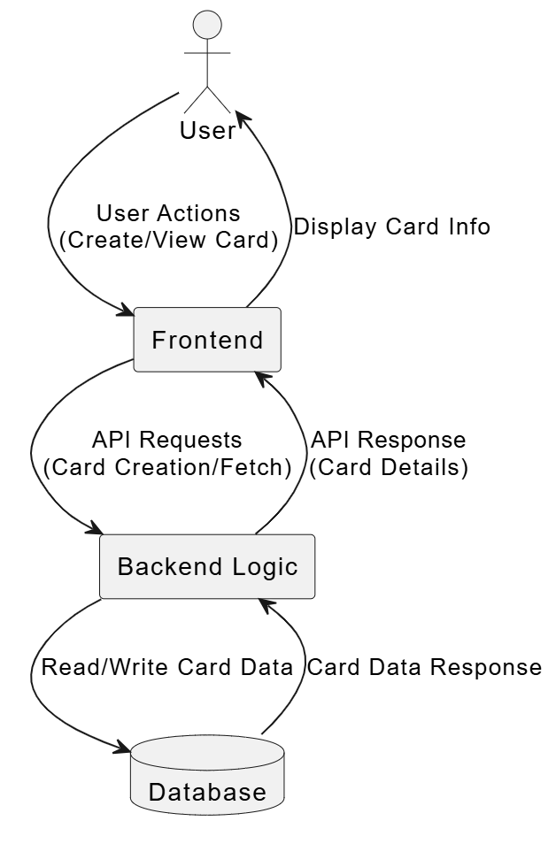

Appendix D: User Interface Screenshots

* Homepage (Login/Register)
* Card Generator Dashboard
* Checkout Simulation Page
* Admin Panel (User and Rate Management)

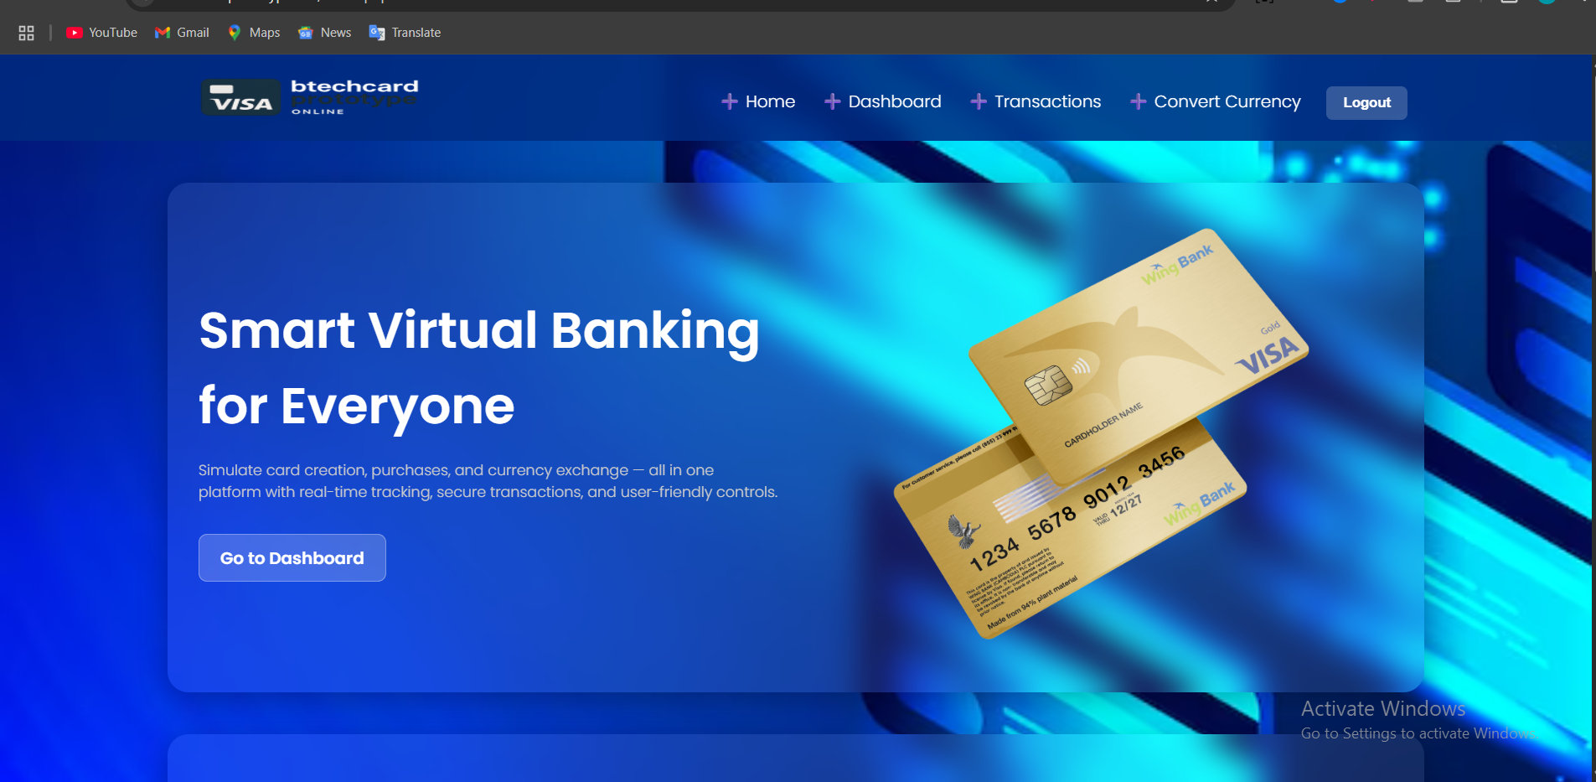

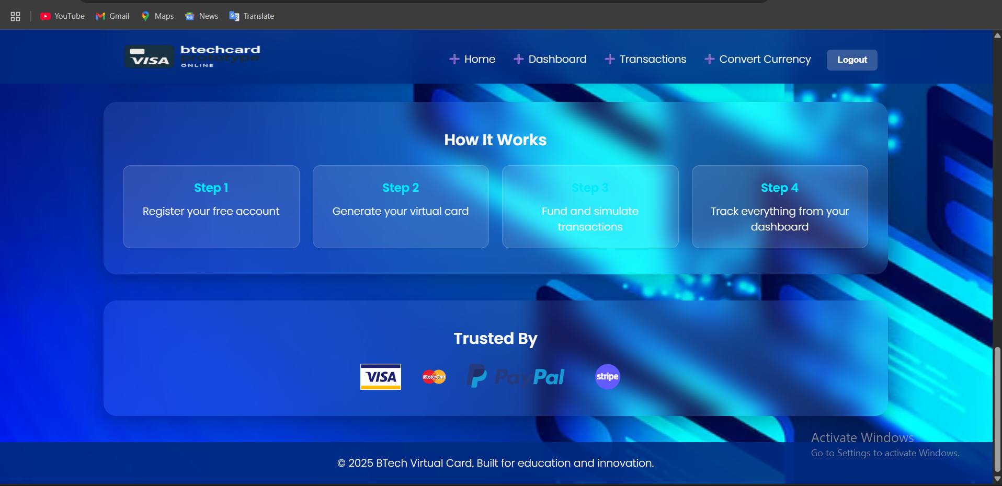



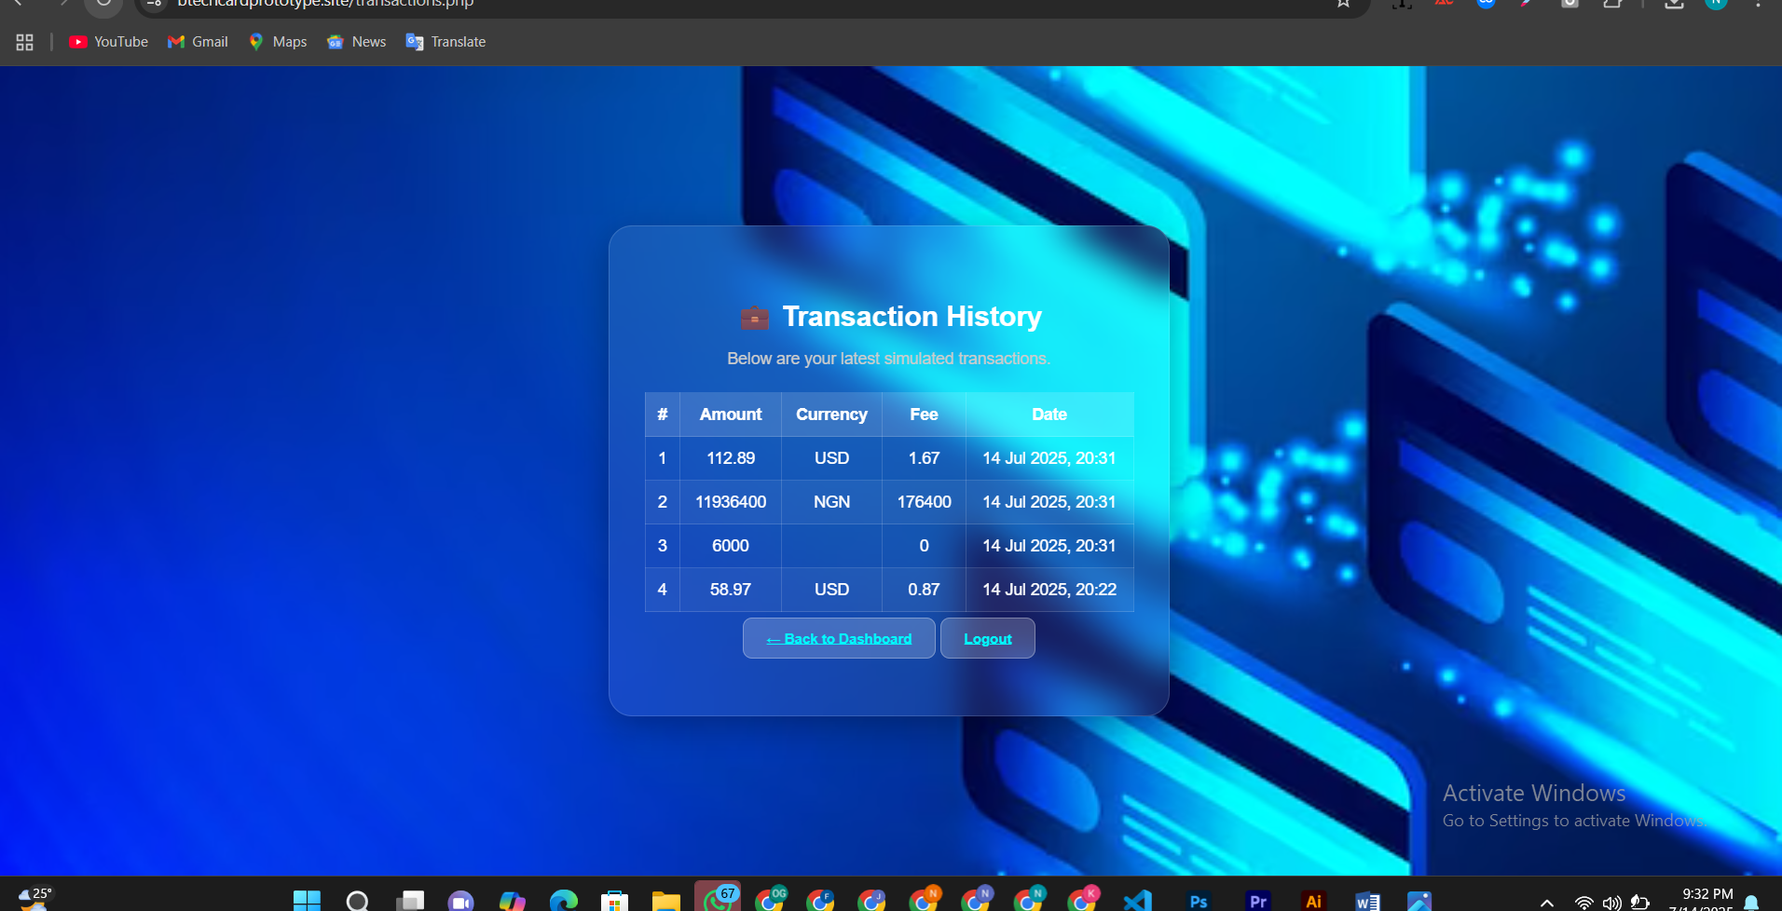

Figure 12 Transactions Dashboard

Appendix E: Questionnaire Sample (Google Form)

Section A: Demographics

1. Age
2. Occupation (Student, Freelancer, Entrepreneur)
3. Gender

Section B: Digital Finance Experience

1. Have you used a virtual card before?
2. Do you understand currency conversion?
3. Have you experienced high transaction fees before?

Section C: Simulation Feedback

1. Did this platform help you understand how virtual cards work?
2. Rate the ease of use of the platform (1–5)
3. Would you recommend this to others for learning?